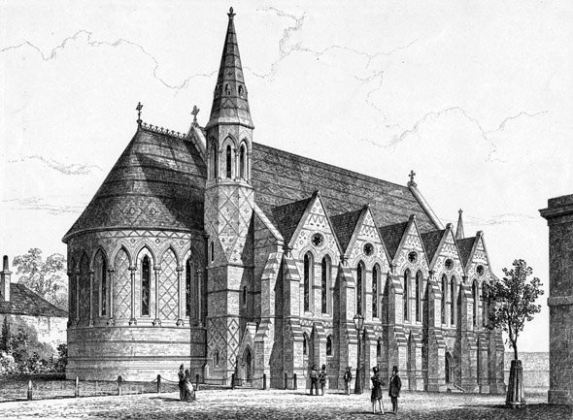
Communication Problems
In a certain occasion a British family went to Germany on holiday. During a walk, the members of that family saw a small country house which they thought would be good for a summer vacation. They talked to the owner, a protestant pastor and asked him to show them the house. They were pleased with it and decided to rent it for the following summer.
After they got back to England, they discussed very much about the house plan, when suddenly the lady remembered she did not see the W.C. So, confirming the practical British sense of the family, they wrote to the pastor to get more details. The e-mail was written in this way:
“Dear pastor,
I am a member of the family which s short time ago visited you in order to rent your house for the coming summer, but as we forgot a very important detail we would appreciate if you could inform us where the W.C. is located.
Mrs. Elizabeth Johansen.”
The German pastor misunderstood the meaning of the abbreviation W.C. and thought it stood to the chapel of the religious sect “White Chapel” so he answered the e-mail this way:
“Dear lady,
I received your e-mail and I am glad to inform you that the place you inquired me about is located twelve kilometers from the house. This might be quite inconvenient, especially for people who are used to going there frequently. In this case, it is preferable to bring some food with you and stay there all day long. Some people go on foot and others go by bicycle. There is space for four hundred people sitting and one hundred standing. The air is conditioned to avoid common discomfort in agglomerations. Seats are on velvet (we recommend you to arrive early to take a seat).
Children remain beside adults and everybody sings in chorus. In the start a sheet is given to each person but if someone arrives late he or she can share one with their neighbor. The same sheet must be returned in the end to be used all month. Everything that is collected is for the poor children of the region. Special photographers take photos to the local newspapers so that everyone can see their fellows in so human duty…”

EXERCISE
- The problem of communication is attributed because:
- The lady didn’t write the word without abbreviating.
- The family and the pastor were from different countries.
- The family and the pastor had different cultural background about the abbreviation.
- The pastor was not intelligent enough to know the word.

- The family understood for W.C.:
- a Church.
- a yard.
- a bathroom.
- a cellar.

- The pastor understood for W.C.:
- a Church.
- a yard.
- a bathroom.
- a cellar.

- How many people can attend the W.C section according to the pastor?
__________________________________________________________________________________

- What does it mean in English the abbreviation “W.C.”?
__________________________________________________________________________________

- Why is this text funny?
__________________________________________________________________________________
__________________________________________________________________________________

- Match the words with their synonyms or definitions:
- country house ( ) bathroom
- owner ( ) a fabric of silk, cotton, nylon, etc, with a thick close soft usually lustrous pile.
- rent ( ) happy
- W.C. ( ) a piece of (printed) paper.
- sect ( ) grange, house party.
- misunderstand ( ) legal possessor.
- glad ( ) to occupy or use (property) in return for periodic payments.
- preferable ( ) to fail to understand properly.
- velvet ( ) a religious group regarded as extreme or heretical.
- sheet ( ) desirable

- What does it mean “fellow”?
- informal one or oneself: a fellow has to eat
- (often plural) a companion; comrade; associate
- a person in the same group, class, or condition: the surgeon asked his fellows
- one of a pair; counterpart; mate
- All answers above are correct.

- The synonym for “all day long” is…
- The whole day
- Someday
- Wednesday
- Every day

- Did you like the text? Write a paragraph about it.
__________________________________________________________________________________
__________________________________________________________________________________
__________________________________________________________________________________
__________________________________________________________________________________

