
WHO IS THE BURGLAR?
30 Conversation Cards










Name: Mary Johnson
Age: 22
Job: restaurant chef
Home: Arizona
Hobby: reading novels
Family: engaged, no kids
Pet: no
Shoe size: EUR 40, US 7,5
(1)

Name: James Williams
Age: 30
Job: business man
Home: Florida
Hobby: go skiing
Family: married, 1 son
Pet: cat Molly
Shoe size: EUR 45, US 11,5 (2)

Name: Trisha Jones
Age: 36
Job: doctor
Home: Kansas
Hobby: listening to music
Family: married, 2 daughters
Pet: dog Max
Shoe size: EUR 40, US 7,5 (3)

Name: Harry Brown
Age: 41
Job: judge
Home: North Carolina
Hobby: playing golf
Family: divorced, no kids
Pet: no
Shoe size: EUR 45, US 11,5
(4)
Name: Linda Davis
Age: 30
Job: scientist
Home: Arizona
Hobby: go dancing
Family: married, no kids
Pet: no
Shoe size: EUR 40, US 7,5 (5)

Name: Elizabeth Miller
Age: 19
Job: student
Home: Minnesota
Hobby: watching movies
Family: single, no kids
Pet: turtle Lucky
Shoe size: EUR 38, US 6
(6)
Name: Jenny Wilson
Age: 12
Job: student
Home: Hawaii
Hobby: go swimming
Family: single, no kids
Pet: hamster Fiffy
Shoe size: EUR 38, US 6
(7)
Name: Susan Moore
Age: 22
Job: teacher
Home: California
Hobby: playing scrabble
Family: married, 1 daughter
Pet: budgie Gertie
Shoe size: EUR 40, US 7,5
(8)









Name: Betty Taylor
Age: 19
Job: student
Home: Texas
Hobby: go swimming
Family: single, no kids
Pet: cat Charlie
Shoe size: EUR 40, US 7,5
(9)

Name: Robert Anderson
Age: 30
Job: builder
Home: Arizona
Hobby: watching movies
Family: married, 2 daughters
Pet: dog Sam
Shoe size: EUR 45, US 11,5
(10)

Name: Helen Jackson
Age: 59
Job: grandma
Home: Kansas
Hobby: reading novels
Family: married, 3 sons
Pet: poodles Jill and Joe
Shoe size: EUR 40, US 7,5
(11)
Name: William White
Age: 22
Job: professional hockey player
Home: Minnesota
Hobby: go skiing
Family: single, no kids
Pet: no
Shoe size: EUR 42, US 8,5
(12)

Name: Nancy Harris
Age: 36
Job: housewife
Home: California
Hobby: go dancing
Family: married, 2 sons
Pet: dog Simba
Shoe size: EUR 40, US
7,5 (13)

Name: Chris Thompson
Age: 41
Job: journalist
Home: Hawaii
Hobby: playing scrabble
Family: divorced, 1 son
Pet: no
Shoe size: EUR 45, US 11,5 (14)

Name: Paul Martin
Age: 55
Job: musician
Home: Florida
Hobby: go hiking
Family: divorced, no kids
Pet: no
Shoe size: EUR 45, US
11,5 (15)

Name: Steven Robinson
Age: 36
Job: artist
Home: North Carolina
Hobby: listening to music
Family: married, no kids
Pet: cat Misty
Shoe size: EUR 45, US 11,5
(16)









Name: Ryan Clark
Age: 22
Job: college student
Home: California
Hobby: watching movies
Family: single, no kids
Pet: no
Shoe size: EUR 42, US 8,5 (17)

Name: Lilly Green
Age: 22
Job: marketing manager
Home: Texas
Hobby: go skiing
Family: engaged, no kids
Pet: cat Princess
Shoe size: EUR 40,
US 7,5 (18)

Name: Larry Baker
Age: 59
Job: actor
Home: Arizona
Hobby: playing scrabble
Family: married, 2 sons
Pet: dogs Duke and Codey
Shoe size: EUR 45, US 11,5 (19)

Name: Shirley Adams
Age: 30
Job: accountant
Home: Hawaii
Hobby: go dancing
Family: married, 1 son
Pet: hamster Jonny
Shoe size: EUR 40, US 7,5
(20)

Name: Jeffrey Turner
Age: 36
Job: tailor
Home: Kansas
Hobby: listening to music
Family: married, 1 son
Pet: no
Shoe size: EUR 45, US 11,5 (21)

Name: Scott Phillips
Age: 22
Job: unemployed
Home: North Carolina
Hobby: go swimming
Family: girlfriend, no kids
Pet: a dog and a cat.
Shoe size: EUR 42, US 8,5
(22)

Name: Kevin Parker
Age: 55
Job: scientist
Home: Florida
Hobby: playing golf
Family: married, no kids
Pet: white mouse Skippy
Shoe size: EUR 45, US
11,5 (23)

Name: Brenda Murphy
Age: 12
Job: student
Home: Minnesota
Hobby: reading novels
Family: single, no kids
Pet: cat Rupert
Shoe size: EUR 38, US 6
(24)










Name: Amy Morris
Age: 30
Job: fire fighter
Home: Texas
Hobby: listening to music
Family: boyfriend, 1 son
Pet: no
Shoe size: EUR 40, US 7,5
(25)

Name: Jason Roger
Age: 36
Job: lumberjack
Home: North Carolina
Hobby: go hiking
Family: married, no kids
Pet: dog Buster
Shoe size: EUR 45, US 11,5
(26)

Name: Anny Howard
Age: 12
Job: student
Home: Arizona
Hobby: watching movies
Family: single, no kids
Pet: cats Jim and John
Shoe size: EUR 38, US 6
(27)

Name: Carl Peterson
Age: 41
Job: janitor
Home: Hawaii
Hobby: playing scrabble
Family: divorced, 1 son
Pet: turtle Tom
Shoe size: EUR 45, US 11,5
(28)

Name: Scott Grey
Age: 19
Job: graduated student
Home: Florida
Hobby: go skiing
Family: engaged, no kids
Pet: hamster Spike
Shoe size: EUR 42, US 8,5
(29)

Name: Terry Coleman
Age: 41
Job: news caster
Home: California
Hobby: reading novels
Family: married, 2 sons
Pet: dog Gizmo
Shoe size: EUR 45, US 11,5 (30)

You are a civilian
You
are the burglar

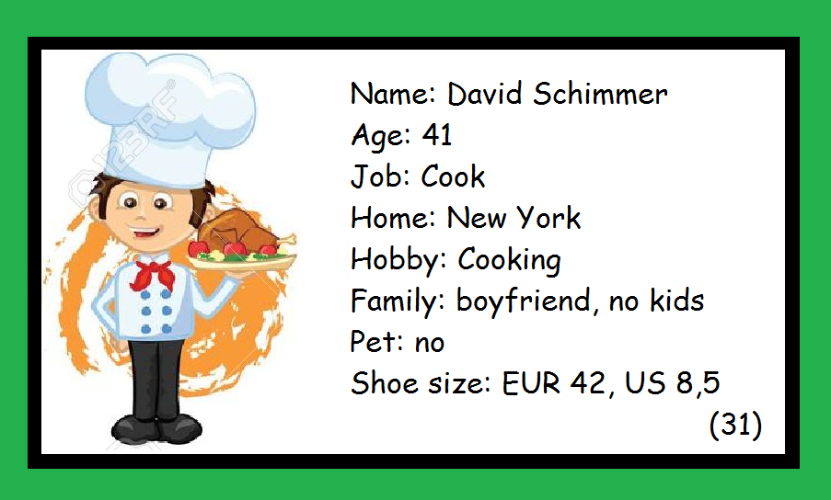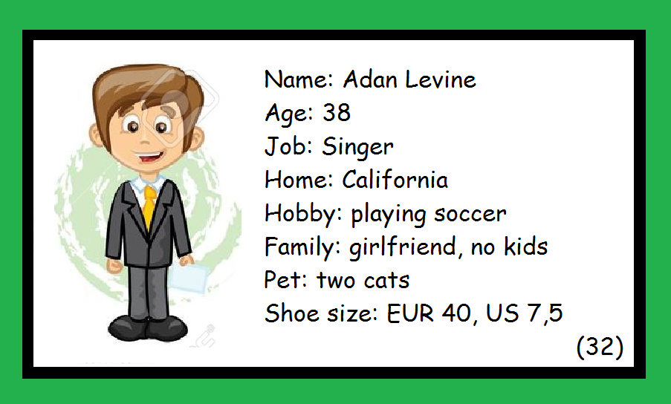

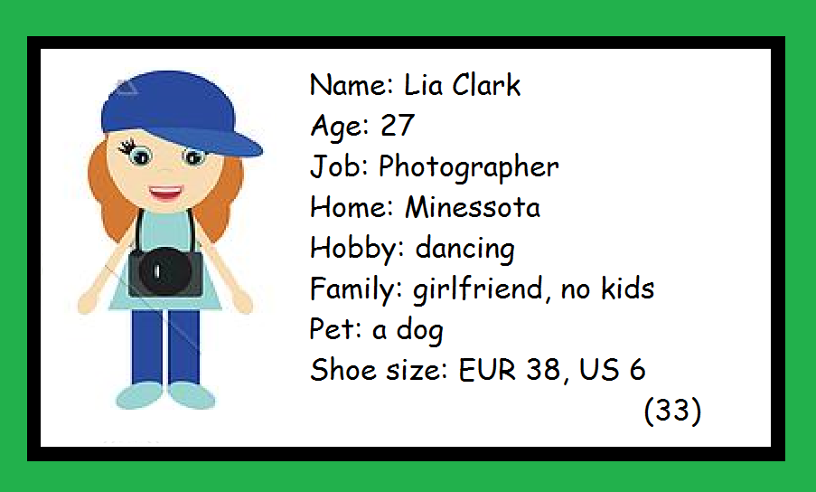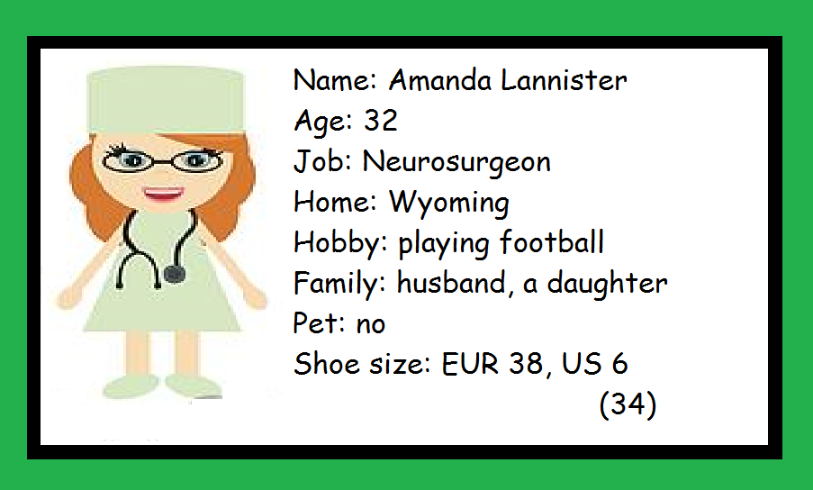

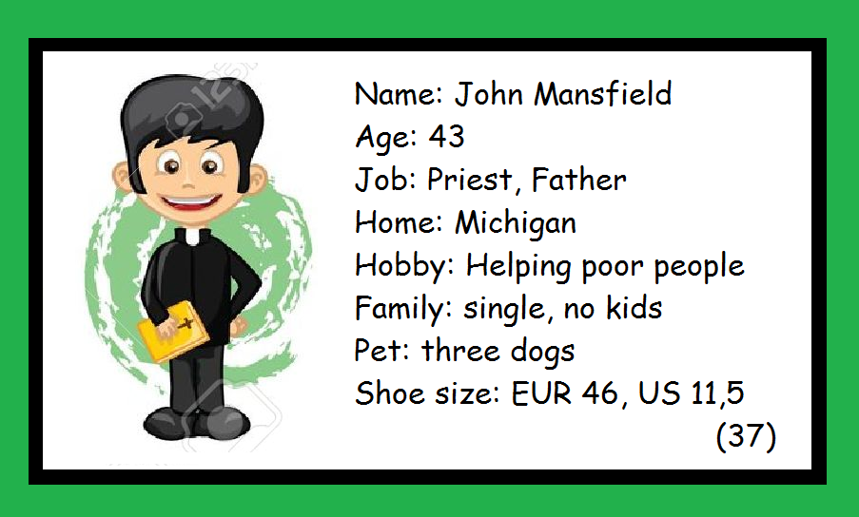
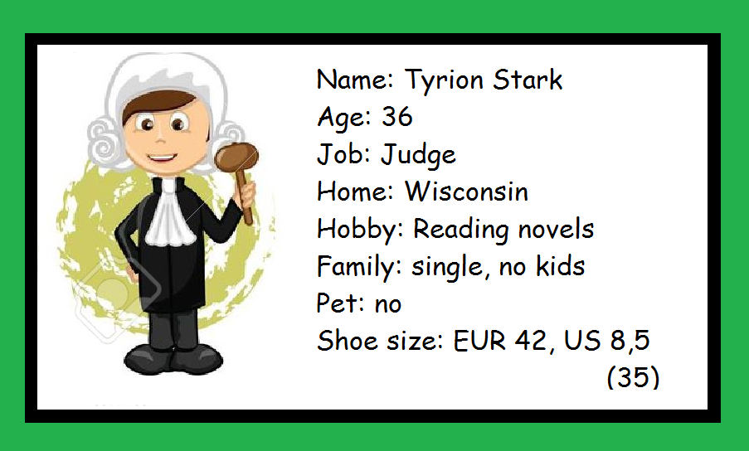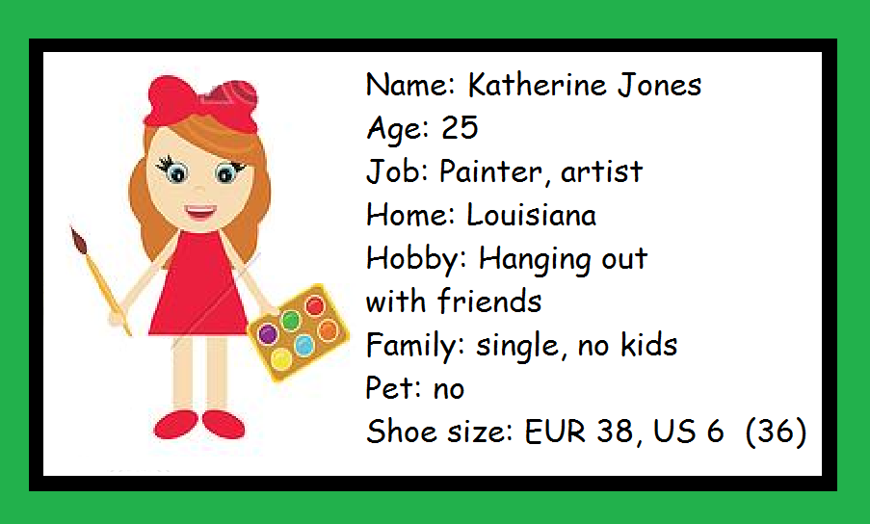
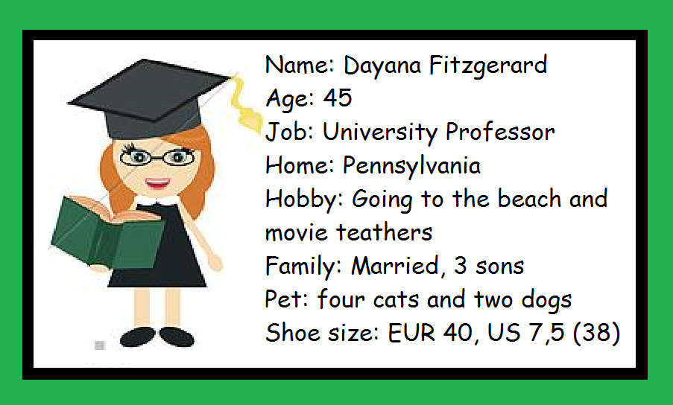

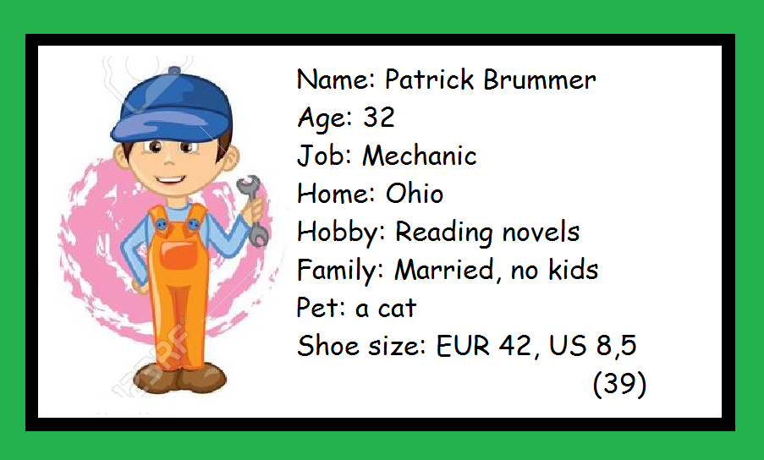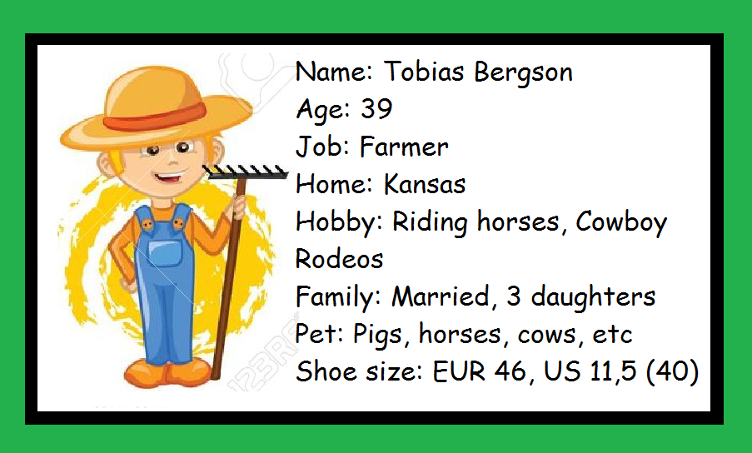

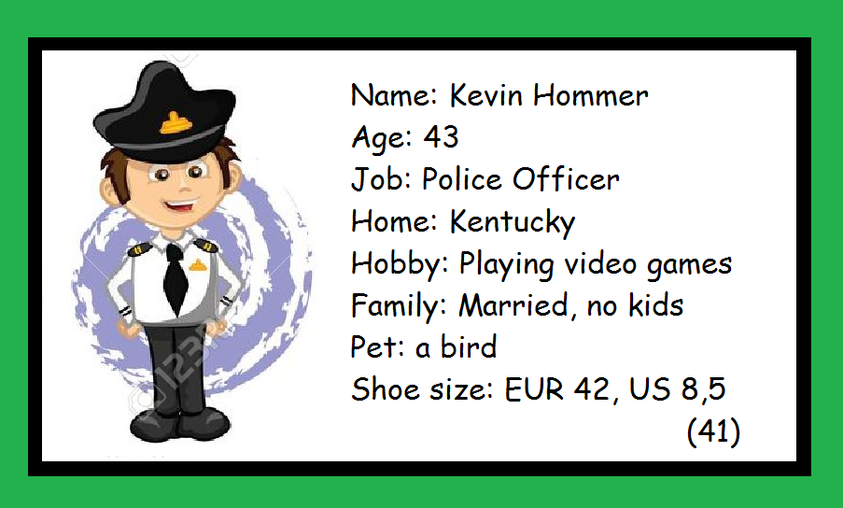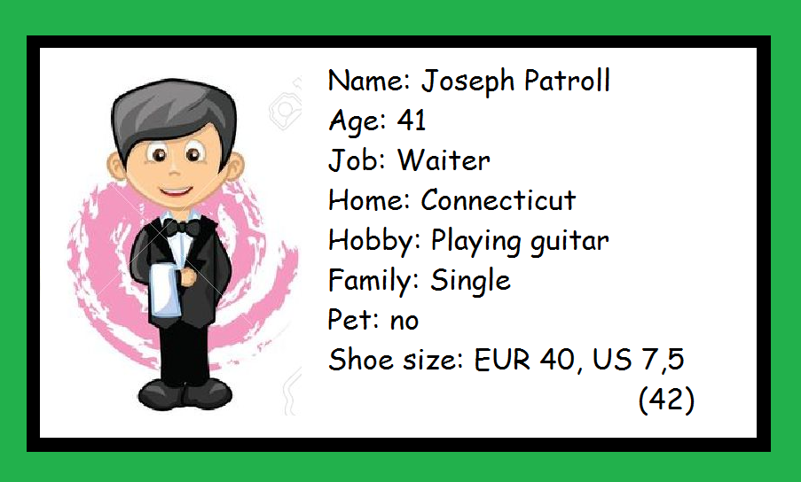

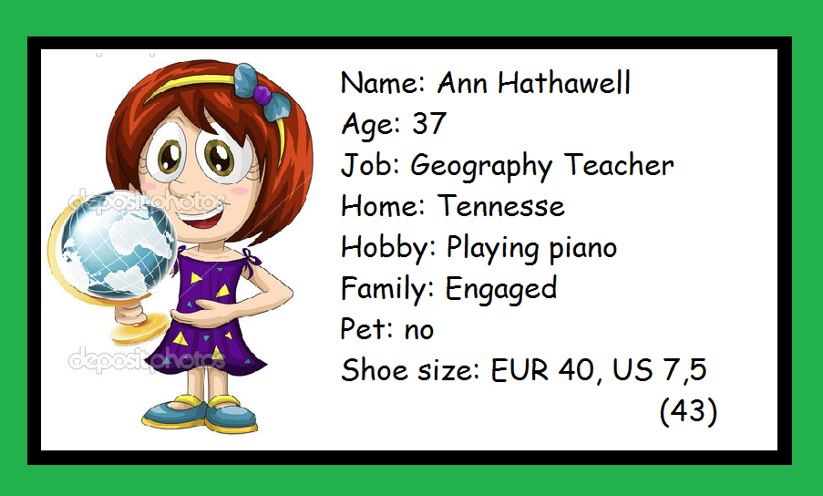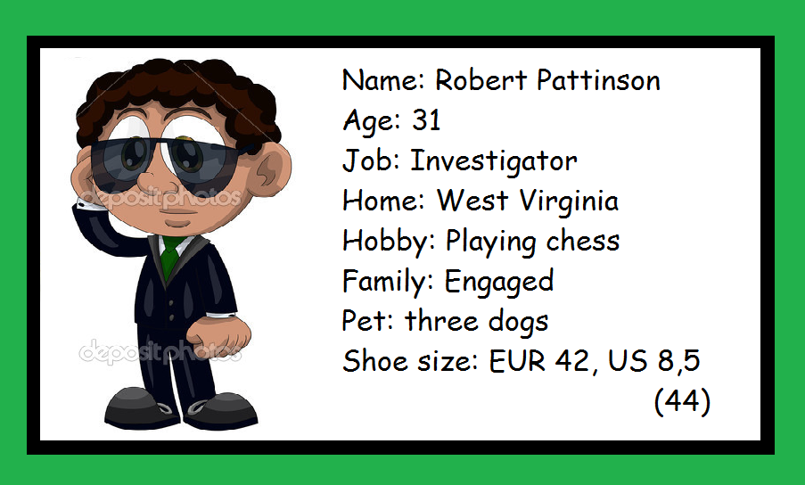

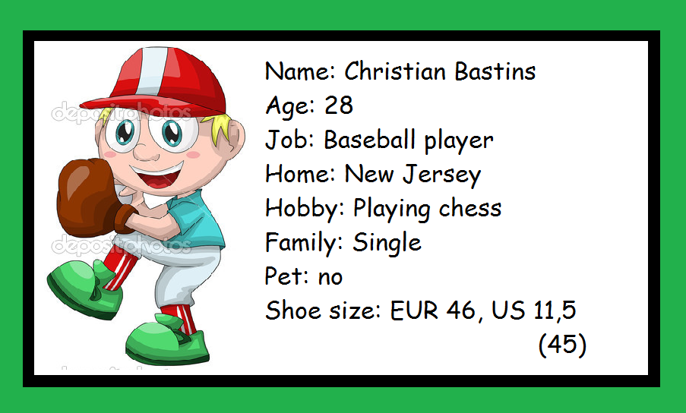

There was a murder in apartment in New York City. In the house of Jasmine Schimmer the police found her body on the floor. She had been shot three times. The investigators found some messages on Jasmine social media addressed to her by a person whose nickname was “Big Friend” and some evidence on the crime scene. By the social media messages, the police learned that the man/woman who committed the crime must be a young person. The bullets found on Jasmine body were from a gun that was registered in the name of a man called Mark Phillips who had robbed a bank – the gun was thrown in the trash after the robbery (the man told the police). Jasmine had a postcard addressed to Jasmine from North Carolina signed “love”. They found a footprint (with traces of wet ground) in her front door size 8,5 (US). In the ground they found chlorine (from pools) mixed with the wet ground. Her purse was on the floor and there was sing of robbery (no money in her wallet). Her notebook and jewellery were missing. Her apartment was very messy (as someone had looked for something valuable). On her body was found hair of a cat and a dog and of a mysterious man. The analyses did not show the man’s identity but they learned he was a relative of the bank robber Mark.

She lived alone but had a sister who helped police to say the things that were missing in her house. Her sister said she was dating a guy from the internet and was supposed to meet him that day. Her sister had had a fight with Jasmine the day before. Neighbours heard Sandra (Jasmine sister) saying she would like to see her dead. One of her classmates, Scott, in the college she was, used to be stalking her (sending flowers and candies) but she said she wasn’t interested. She told the school principal about it and the man was called to explain – he didn’t do it again after this meeting with school principal, but he got really angry with Jasmine – she was a bit afraid of meeting him in school. She used to talk with her priest, father John about her problems. She barely knew he was accused in the past of stalking women – he had secret desire on Jasmine and used to be very nice to her always and he used to say to Jasmine to stay after prayer for talking late in the night. One of her professors did not treat Jasmine well (people thought she was jealous about Jasmine intelligence) and used to be very mean to her. She accused this Professor Dayana of bullying her and the professor was suspended for three months by the time of her murder. Lia Clark was a friend of Jasmine and she used to be very jealous about her and she did not enjoy Jasmine’s virtual relationship – people thought the girls had a kind of secret affair. Jasmine had finished a relationship two months before her death with a much known journalist called Chris. He was abusive with her (used to beat her and make her feel bad). She did not want to prosecute him and decided to finish the relationship. All her friends thought he could have killed Jasmine. Katherine Jones was Jasmine best friend and she was concerned about this new relationship of her friend by the internet. One of this mysterious guy’s messages made Kathy feel worried about her friend. He said he was in trouble and needed some money to pay his bills. He asked Jasmine if she had some to lend him. Katherine said to Jasmine not to lend money because she did not know this man. However, Jasmine was really in love and that afternoon she took R$ 5,000.00 of her bank account to lend this man she had never met. Jasmine had a brother too. His name was David. Jasmine had denied lending money to Jasmine because he used to play cards and he always owed money to someone.

What’s your name?
What’s your job? What do you do?
Where are you from?
What are your hobbies?
Are you married?
Do you have any children?
Do you have a pet?
What size is your foot?
Did you kill Jasmine?
Who is your father?

