His name is Tobias Eaton, but people call him Four. He is Marcus’s son. He is quiet. He is 18 years old.
- He chooses Dauntless at his Choosing Ceremony. [Divergent 4]
- He gives the initiates a tour of Dauntless HQ. [Divergent 7]
- He’s been asked to become a Dauntless leader several times, and refuses. [Divergent 7]
- He teaches the initiates how to shoot a gun; he is good. [Divergent 8]
- He gives Tris fighting tips. [Divergent 11]
- He picks the fastest initiates and members for his capture the flag team. [Divergent 12]
- His team wins capture the flag. [Divergent 12]
- He teaches the initiates how to throw knives. [Divergent 13]
- He finds out that Tris is Divergent and warns her to hide it. [Divergent 20]
- He saves Tris from Eric by lying about why she left Dauntless HQ[Divergent 28]

What’s his name?
How old is he?
Where is he from?
What does he do?
Does he know Tris?
Does he fight for her?
Does his team capture the flag?
Does he warn Tris to hide?
Does he know Tris is divergent?
Does he save Tris from Eric?
Do they begin a relationship?
Do you like this movie?

Her name is Beatrice Prior, but people call her Tris. She is Nathalie and Andrew’s daughter. She is brave. She is 16 years old.
- The results of her Aptitude test were inconclusive- showing equal aptitude for Abnegation, Dauntless, and Erudite. [Divergent 3]
- She chooses Dauntless at the Choosing Ceremony. [Divergent 5]
- She’s on Four’s Capture the Flag Team. [Divergent 12]
- Find out where Eric‘s Team is hiding their flag by climbing the Ferris Wheel with Four. [Divergent 12]
- Four saves her when Peter, Drew, and Al take her and hang her over the Chasm. [Divergent 21]
- She doesn’t forgive Al when he apologizes. [Divergent 23]
- She gets caught in the Erudite Sector and has to speak with Jeanine. [Divergent 28]
- Her mom saves her from drowning. Her mom dies saving her. [Divergent 35]
- Her dad dies saving her. [Divergent 37]
- She refuses to kill Four and saves him. [Divergent 38]

What’s her name?
How old is she?
Where is she from?
What does she do?
Does she know Tobias?
Does she know how to shoot?
How does she captures the flag?
Where does she choose to be at the ceremony?
Does she forgive Al?
Does she get caught?
Does her mother visit her?
Does she kill Four?

His name is Caleb Prior. He is Nathalie and Andrew’s son. He is older than Tris by 9 months, and doesn’t really look like her. He is good looking and good at being selfless. After his Aptitude test he is pale and his palms are sweating, his fingers shake. He appears calm during the choosing ceremony.

- Tells Tris that even though they should think of their families before choosing a Faction, they must also think of themselves. It’s the first time she’s ever heard him be selfish. [Divergent 4]
- Holds Tris’s hand during the Choosing Ceremony until it’s his turn to choose. [Divergent 5]
- He’s in Tris’s Fear Landscape [Divergent 30]
- After researching the simulation serum, he leaves Erudite Initiation. [Divergent 36]
- Proves his book smartness by removing the bullet from Tris’s shoulder and stitching it up. [Divergent 36]
- Goes with Tris to Dauntless HQ because he knows the most about the Erudite plan. [Divergent 37]
- Tris saves him by making him stay with Peter. [Divergent 37]
- Heads to the Amity Sector with Tris, Four, Peter, and Marcus. [Divergent 39]

What’s his name?
How old is he?
Where is he from?
What does he do?
Does he know Tris?
Does he fight with her?
Does he hold Tris hand at the ceremony?
Does he know the Erudite plan?
Does he know Tris is divergent?
Does he save Tris?
Do they head to the Army Sector?
Do you like him?

Her name is Jeanine Mathews. She seems to be around forties. She has sharp, but attractive eyes. She sees problems and forms solutions based on the data she collects.

- She is Erudite‘s only city council representative, she was selected based on her IQ store. [Divergent 4]
- Before she was a leader, she worked with Cara. They were trying to develop a longer-lasting serum for the simulations. [Divergent 25]
- She is the voice behind the simulations for the Aptitude Test. [Divergent 28]
- She developed the Aptitude Test. [Divergent 28]
- She developed the serum that was injected into the Dauntless, turning them into “sleepwalkers”. [Divergent 34]
- She wants a new government based on wealth, comfort, and prosperity. [Divergent 34]
- She developed a serum for the Divergent. [Divergent 34]
- She injects Four with the Divergent serum and sends him to the Control Room. [Divergent 34]
- She sends Tris to Room B13 to be executed. [Divergent 34]

What’s her name?
How old is she?
Where is she from?
What does she do?
Does she like Tris?
Does she fight with her?
Does she develop serum?
Does she inject serum on Tris?
Does she know Tris is divergent?
Does she kill Tris?
Do they fight?
Does she want a new government based on good things?

His name is Peter. He is 16 years old. He’s tall, with dark, shiny hair. He has a wide white smile. His eyes are wide and dark green.
- Taunts Tris from the very beginning. [Divergent 6]
- Beats Tris in the Arena. [Divergent 10]
- On Eric’s team for capture the flag. [Divergent 12]
- He and Drew are the only ones missing when Edward is stabbed in the eye. [Divergent 16]
- He, Drew, and Al take Tris and dangle her over the Chasm. [Divergent 21]
- After Initiation, he wants to be a Dauntless-leader-in-training. [Divergent 32]
- Ranked 5th out of 12 in the final rankings. [Divergent 32]
- Removed from the war simulation by the Dauntless Leaders. [Divergent 37]
- Tells Tris where the control room is only after she agrees to take him with her. [Divergent 37]
- Leaves Dauntless HQ on a Train toward the Amity sector. [Divergent 39]

What’s his name?
How old is he?
Where is he from?
What does he do?
Does he like Tobias?
Does he fight with him?
Does he beat Tobias?
Does he take Tris to be dangled over the Chasm?
Does he want to be a Dauntless leader?
Does he help Tris?
Do they fight together?
Does he capture the flag with Tris?

Her name is Cristina. She is 16 years old. She’s tall with dark brown skin and chin length black hair. She has brown eyes and is pretty and lean. Her teeth are straight on the top and crooked on the bottom. She’s fast and strong. During initiation she got a tattoo of the Dauntless seal.
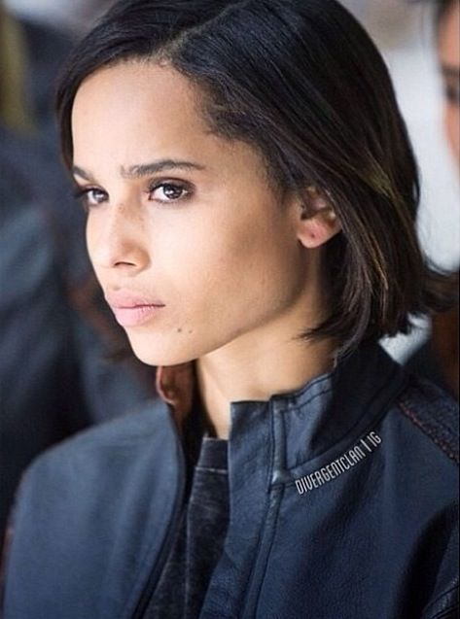
- Helps Tris onto the Train for the first time. [Divergent 6]
- She helps make over Tris. [Divergent 8]
- Tris’s first real friend. [Divergent 9]
- Because she forfeits her first fight, Eric makes her hang over the Chasm for five minutes. [Divergent 9]
- Snatches the flag while playing capture the flag even though Tris gets there first. [Divergent 12]
- Her mom and sister visit her on Visiting Day. [Divergent 15]
- Apologizes to Tris for taking the flag when they played capture the flag. [Divergent 23]
- Wakes Tris up to tell her about Al’s suicide. [Divergent 24]
- She knew that she could never choose to stay in Candor because she doesn’t want to share everything, and she wants to be in control of her own mind. [Divergent 28]
- After initiation ends, she wants a job like Four’s, training initiates. [Divergent 32]
http://www.divergentlexicon.com/characters

What’s her name?
How old is she?
Where is she from?
What does she do?
Does she like Tris?
Does she make Tris hang over the Chasm for five minutes?
Does she develop serum?
Does she get the flag before Tris?
Does she know Tris is divergent?
Does she want a job like Tobias?
Do her mother and sister visit her?
Does she forfeit her first fight?

