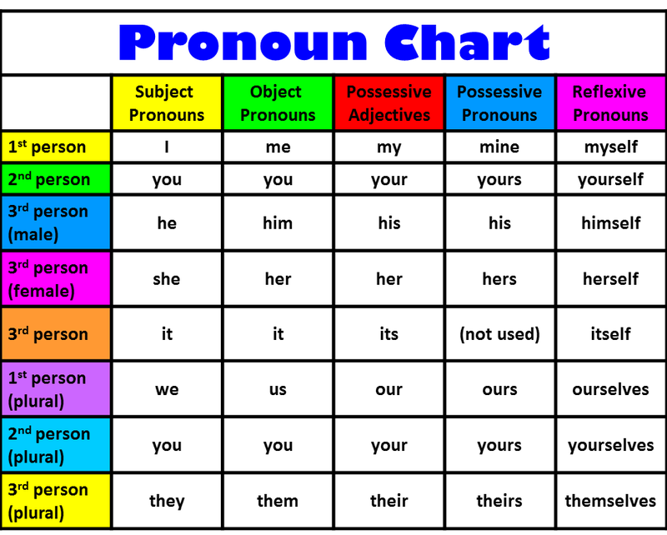

Personal Pronouns – Pronomes Pessoais
Como: Sujeito
Os pronomes são usados em vez do nome do sujeito (entidade) que pratica a ação que predomina na frase. Os pronomes pessoais são em português: eu, tu, ele, ela, nós, vós, eles, elas.

Personal Pronouns – Pronomes Pessoais
Como: Objeto
Os pronomes são usados em vez do nome do objeto da ação que predomina na frase.
Ex: “Eu sou amiga da Georgina.” – “Eu sou amiga dela”: Neste caso a Georgina é o objeto da ação, como tal será utilizado o pronome her. Ficando assim: “I am – HER – friend”

Possessive Adjective – Adjetivos Possessivos
Os adjetivos qualificam o nome que se lhes segue, indicando a posse do sujeito sobre este. Exemplo: This is HER notebook (Este livro é dela).

Possessive Pronouns – Pronomes possessivos
Os pronomes possessivos aparecem em vez do nome do objeto em questão, qualificando-o como propriedade do sujeito. Lucy bought a notebook. I bought a notebook too. Hers is pink, mine is red.

Reflexive Pronouns – Pronomes reflexos
Estes pronomes utilizam-se quando o sujeito faz uma ação que recai sobre ele mesmo, e somente neste tipo de circunstancias. I cut myself (I cut – I was cut). David hurt himself (David hurt someone – David was hurt).

https://brandoaenglish.wordpress.com/category/revisoes/

Demonstrative Pronouns – Pronomes demonstrativos
Os pronomes demonstrativos têm a função de indicar algo. São eles: “this” (este/esta), “that” (aquele/aquela), “these” (estes/estas), “those” (aqueles/aquelas).
 | Singular | Plural
Próximo | THIS | THESE
Distante | THAT | THOSE

Ex: This car is really cool. (Este carro é muito legal).
Ex: That is my new neighbor. (Aquele é o meu vizinho).
Ex: These tickets are too expensive. (Estes ingressos são muito caros).
Ex: Those are my classmates. (Aqueles são meus colegas de classe).

http://brasilescola.uol.com.br/ingles/demonstrative-pronouns.htm
A que estas palavras se referem????
New Zealand is becoming an increasingly popular destination for overseas visitors. Itattracts tourists and people on business, but the vast majority come as students. Mostly from Asian countries, they stay for anything from a few weeks to a few years or more, studying at language schools, colleges and universities. New Zealand can offer good homestay accommodation, a clean and beautiful environment and a reasonable cost of tuition. These factors attract an ever-increasing number of overseas students, accounting for millions of dollars in revenue for New Zealand.

It refers to
(a) overseas
(b) New Zealand
(c) a popular destination

They refers to
(a) Asian countries
(b) tourists and business people
(c) students

These factors refers to
(a) accommodation, environment and reasonable tuition costs
(b) schools, colleges, universities
(c) increasing overseas students

Now try using reference words the other way round. What reference word could replace the underlined words?

- Professor Edwards has been lecturing for 16 years.
- Overseas students often find university courses difficult.
- The IELTS test is becoming increasingly popular.

- Professor Edwards _____________
- Overseas students _____________
- The IELTS test _____________

Tip 1: Subject or object reference words
Be careful – reference words can change depending on whether they are the subject or the object of the sentence. For example:
Overseas students often find university courses difficult.
- They often find university courses difficult.
- Overseas students often find them difficult.
Mr Smith works with Mr Jones every day.
- He works with Mr Jones every day.
- Mr Smith works with him every day.

Tip 2: Singular and plural
When talking generally, you may find that some singular nouns take a plural reference word. For example:
A teacher (singular) should always be prepared. They (plural) should also be punctual.
Tip 3: The dummy subject
Sometimes ‘it’ can appear in a sentence but it is not a true reference word – it doesn’t refer back to anything specific. This is called the dummy subject. For example:

It is commonly accepted that people with a higher education generally work in higher paid jobs.
In the sentence above, ‘it’ does not refer to anything specific, just the general situation.

Practice by reading the sentences below and deciding whether ‘it’ is used as a reference word or a dummy subject.
- Look at those clouds. It’s going to rain.
- Homework is essential. It allows students to review work they have studied in class.
- Admittedly, student depression is hard to investigate as few people are willing to talk openly about it.
- It can take up to four years to complete a degree.
- Otago is a very popular university. It was the first university in New Zealand.
Now test yourself. Read the text below and decide what the underlined reference words refer to.

Academic overdrive?
- Student life is becoming increasingly difficult. Not only are students expected to perform and compete within the class, but also to devote time and energy to extra-curricular activities as well as struggle with an increasing load of homework. The push to get into the top universities has caused many overachieving students to take on heavier workloads and more challenging classes.
- This push, however, doesn’t end once students reach university. In fact, when they reach the top places they have worked so hard to get into, many students are forced to work even harder than they did in high school. Once in the top universities, the pressure is on to secure a place in the top graduate school. But it doesn’t end there. Once students have graduated with the best results, they find that they must continue to overextend themselves in order to secure the top jobs in their particular field. Such is the emphasis on academic success.
- There are many who claim that this entire system is wrong because it puts too much emphasis on measuring achievement and not enough on true learning. This in turn has inevitable effects on the students themselves. In such a high-pressure learning environment, those that find the pressure overwhelming have nowhere to turn. In an academic world measured only by academic success, many students begin to feel a low sense of worth, yet they fear to turn to anyone for help as this would be perceived as a signal of failure, an inability to cope with that which other students appear to have no problem. This can be particularly hard for foreign students as they find themselves isolated without familiar cultural or family ties in their new environment and thus they concentrate solely on their work.
- Perhaps the main thing to remember is that although it is important to study hard, school life should also be fun.

- This push refers to
- They refers to
- It refers to
- There refers to
- This refers to
- Those refers to
- This refers to
- It refers to

http://www.englishpracticeonline.com/understanding-reference-words/
Relative Pronouns – Pronomes relativos
Os pronomes relativos têm a função de ligar frases evitando repetições. São eles:
Esta é a lista referente aos Pronomes Relativos:
Subject | Object | Possessive
*Who / Quem | Who / Whom / Quem | Whose / Cuja, Cujo
Which / Qual / Que | Which / Qual / Que
That / Que | That / Que
Chamamos de pronome relativo o pronome que introduz uma oração relativa. Ele recebe esse nome porque está relacionado à palavra que a oração relativa vai modificar, isso significa que o pronome relativo liga a oração relativa à outra parte do período. Também os usamos quando queremos fazer questionamentos, perguntar algo, para identificar alguém ou alguma coisa, colocar uma nova oração ou acrescentar alguma informação.

Usa-se Who (quem, o qual, a qual) apenas para pessoas.
Usa-se That (que) para coisas e pessoas.
Usa-se Which (o qual, o que, que) para coisas.

Confira o uso do Pronome Relativo nos seguintes exemplos:
The person who called you last night is your mother. / A pessoa que te ligou ontem é sua mãe.
Hey! The cat which is in the garden belongs to me. / Ei! O gato que está no jardim pertence a mim.
The books that are on the bookshelf are mine. / Os livros que estão na prateleira são meus.
The car whose owner is my mom was in the garage. / O carro cuja dona é minha mãe estava na garagem.

Algumas maneiras de usar os Pronomes Relativos:
1- Depois de um substantivo: Seu uso deixa bem claro de que pessoa ou coisa estamos mencionando no contexto:
The apartment that my father live. / O apartamento que meu pai mora.
The man who invented telephone. / O homem que inventou o telefone.
It was a middle age man who attempted to rob a clothing store. / Foi um homem de meia idade quem tentou assaltar uma loja de roupa.

2- Para dizer algo a respeito de alguém ou de alguma coisa:
My brother who lived abroad, wants to travel again. / Meu irmão, que morou fora, quer viajar novamente.
My grandfather, who is 62, has just retired. / Meu avô, que tem 62 anos, acaba de se aposentar.
Today we have fish and salad which is my favourite meal. / Hoje temos peixe e salada, que é minha refeição favorita.

3- O uso de Whose (Cuja, cujo) como forma possessiva:
This is my friend Jane, whose sister went to college with my brother.
Esta é minha amiga Jane, cuja irmã foi para a Universidade com meu irmão.

4- O uso de Whom (a quem) como objeto do verbo ou da preposição.
This is my husband Nick, whom you met at the party 2 years ago. / Este é meu marido Nick, a quem você conheceu em uma festa 2 anos atrás.
This is Nick's sister, with whom I went to mall. / Esta é a irmã do Nick com quem eu fui para o shopping.

* O Pronome Who pode ser usado para se referir a um animal, quando o animal referido possuir nome (Jack, Missy, Sabal), ou nomes conhecidos, como por exemplo: Marley, Lessie, Salem.
http://mundoeducacao.bol.uol.com.br/ingles/relative-pronouns.htm

