Basic Concepts of Food Security: Definition, Dimensions and Integrated Phase Classification
by Yadav Sharma Bajagai

"Food Security" is one of major elements of development and poverty alleviation and has been the goal of many international and national public organizations. The issue is so important that according to the state of food insecurity in the world 2012 published by FAO around 870 million people (out of which 852 million from developing countries) are estimated to have been undernourished in the period 2010-12. Although the phrase "Food Security" is being used widely, the definition and concept of food security is elusive and being evolved and expanded over time.

Definition of Food Security
Defining food security precisely is very difficult. There are more than 200 definitions and 450 indicators of food security. Following are some popular definitions of food security:

1996 World Food Summit: "Food security exists when all people, at all times, have physical and economic access to sufficient, safe and nutritious food that meets their dietary needs and food preferences for an active and healthy life."

World Health Organization (WHO): "Food security means that:
- all people at all times have both physical and economic access to enough food for an active, healthy life;
- the ways in which food is produced and distributed are respectful of the natural processes of the earth and thus sustainable;
- both the consumption and production of food are governed by social values that are just and equitable as well as moral and ethical;
- the ability to acquire food is ensured;
- the food itself is nutritionally adequate and personally and culturally acceptable; and
- the food is obtained in a manner that upholds human dignity."

Similarly Community Food Security has been defined as follows:

"Community food security exists when all citizens obtain a safe, personally acceptable, nutritious diet through a sustainable food system that maximizes healthy choices, community self reliance and equal access for everyone." - Public Health Association of British Columbia (PHABC)

From these definitions, achieving food security seems utopian (at least ideal) and no country could hope to reach in reality. Therefore, for specific program/project or particular nation definition of food security should be something achievable or measurable at least for certain duration. But, these definitions should cover the basics. No mater how we define food security, having enough to eat regularly for active and healthy life is the most essential human need. Many developing countries, especially in South Asia and Africa, haven't been able to fulfil this vital need even today.

Household Food Security

A household is food secure when it has access to the food needed for a healthy life for all its members (adequate in terms of quality, quantity, and safety and culturally acceptable) and when it is not at undue risk of losing such access.

Food security at global or national level may not usually address the household level food security problem. The relationship between national food security and household food security is less prominent in developing countries than in developed ones. Therefore, specific policies are required to address household level food insecurity and these policies should be contextual and problem-specific.

Characteristics of household with very low food security
- Members of household (mainly adult) worried that their food would run out before they got money to buy more.
- Food they bought just didn't last and they didn't have money to get more.
- They couldn't afford to eat balanced meals have to rely on inexpensive non-nutritious food.
- An adult had to cut the size of meals or skipped meals because there was not enough money for food.
- They had to eaten less than they felt they should because there was not enough money for food.
- They had been hungry but did not eat because they could not afford enough food.
- They had to acquire food through socially unacceptable means such as charitable assistance, buying food on credit etc.

Intra-household food dynamics and consequences during food insecurity are depicted in figure 1.

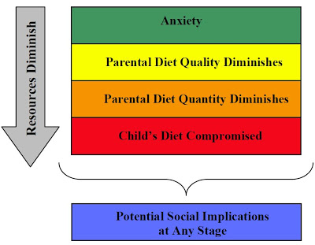
Figure 1: Consequences of Food Insecurity in Households.
Adapted from Hamelin et. al. (1999)

Types of Food Insecurity

Chronic Food Insecurity

Lack of minimum requirement of food to the people for a sustained period of time due to extended periods of poverty, lack of assets and inadequate access to productive or financial resources can be called as Chronic Food Insecurity.

Acute or Transitory Food Insecurity

Sudden lack of food or reduction in the ability to produce or access minimum requirement of food due to short-term shocks and fluctuations in food availability and food access, including year-to-year variations in domestic food production, food prices and household incomes can be defied as Acute or Transitory Food Insecurity.

Dimensions of Food Security
Food security is the outcome of food system operating efficiently. Efficient food system contributes positively to all dimensions of food security. Following are the dimensions of food security (figure 2):

Food availability

This dimension addresses supply side of the food security and expects sufficient quantities of quality food from domestic agriculture production or import. This is simple mathematical calculation weather the food available in certain territory/country is enough to feed the total population in that particular territory and calculated from the level of local agriculture production at that territory, stock levels and net import/export.

This dimension of food security at different levels can be assessed by precipitation record, food balance sheet, food market survey, agricultural production planet. Similarly, indicators of food security for this dimension at different levels are fertility rate, food production, population flows, harvesting time, staple food production, food storage, consumption of wild foods etc.

Food access

Having sufficient food at national level or at certain territory cannot be taken as the proof that all the household or individuals in the country/territory have enough food to eat. Food access is another dimension of food security which encompasses income, expenditure and buying capacity of households or individuals. Food access addresses whether the households or individuals have enough resources to acquire appropriate quantity of quality foods.

Some of the indicators of this dimension at different levels are food price, wage rate, per capita food consumption, meal frequency, employment rate etc. and the dimension can be assessed by Vulnerability Analysis and mapping (VAM), Food Access Survey, Food Focus Group Discussion, Intra- household food frequency questionnaire etc. Interventions to improve this dimension of food security are inter alia on-farm, off-farm and non-farm employment creation, school-feeding program, breast –feeding campaign etc.

Food utilization

Food utilization is another dimension of food security which addresses not only how much food the people eat but also what and how they eat. It also covers the food preparation, intra-household food distribution, water and sanitation and health care practices. The nutritional outcome of the food eaten by an individual will be appropriate and optimum only when food is prepared/cooked properly, there is adequate diversity of the diet and proper feeding and caring practices are practiced.

Stunting rate, wasting rate, prevention of diarrhoeal diseases, latrine usage, weight-for-age, goitre, anaemia, night blindness etc are the indicators at different level for this dimensions which can be assessed by demographic and health survey, immunization chart etc.

Stability

This dimension addresses the stability of the other three dimensions over time. People cannot be considered food secure until they feel so and they do not feel food secure until there is stability of availability, accessibility and proper utilization condition. Instability of market price of staple food and inadequate risk baring capacity of the people in the case of adverse condition (e.g. natural disaster, unexpected weather etc), political instability and unemployment are the major factors affecting stability of the dimensions of food security.

This dimension of food security can be assessed by Global Information Early Warning System, Anthropometric survey, weighing chart of pregnant women etc against certain indicators like food price fluctuation, women etc. against certain indicators like food price fluctuation, women's BMI, pre-harvest food practice, migration etc. Interventions to address this dimension are saving and loan policy, inter-household food exchange, grain bank, food storage etc.

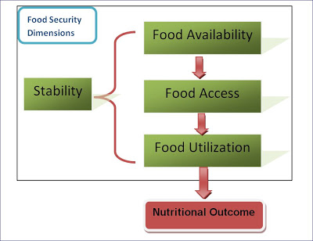
Figure 2: Dimensions of Food Security

In summary, Availability covers whether adequate food is ready at people's disposal while Access ensures if all households and individuals have adequate resources to obtain the food they need either through production or purchase. Similarly utilization is about human body function to adequately ingest, digest and metabolize the food. Stability is about assurance of continuation of fore-mentioned dimensions.
Integrated Food Security Phase Classification (IPC)
The integrated Food Security Phase Classification (IPC) is a tool to classify severity of food insecurity based on a range of livelihood needs. This is a standardized framework for situation analysis expressed in a scale that integrates food security, nutrition and livelihood related information into a clear statement of food security status.

Objectives of IPC
- Provide technical consensus and a common language for classifying severity and causes of food insecurity situations.
- Promote transparency about food security situation through evidence based analysis.
- Communicate about the food security situation to decision makers
- Provide basis for current and early warning projections.

There are 4 components of the IPC: (1) Reference Table (2) Analysis Template (3) Cartographic Protocols (4) Population Table.

This system classify food security/insecurity into 5 different phases (figure 3) by analysing crude mortality rate, acute malnutrition, disease, food access/availability, dietary diversity, water access/availability, destitution and displacement, civil security, coping and livelihood assets.
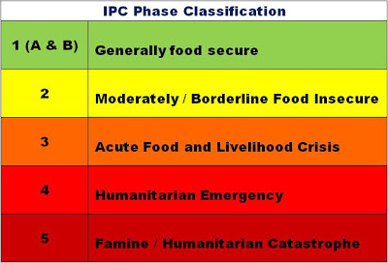
Figure 3: Phases of Food Security according to IPC Phase Classification
http://www.foodandenvironment.com/2013/01/basic-concept-of-food-security.html

