DATA: 23 / 11 / 2016
ALUNO(A):
3º Bimestre
TURMA: 1º INFOR_MAT
PROFESSORA: CRISTIANE DE BRITO CRUZ PROVA TIPO 2

Nota
Valor 100

AVALIAÇÃO BIMESTRAL .
INSTRUÇÕES:
- Leia as instruções com atenção.
- Entregue junto com a prova: seu cartão de vistos e seu trabalho (não será dado outro prazo para entrega).
- Escreva seu nome completo com letra legível. Seus dados de identificação são importantes;
- Não esqueça de preencher o gabarito, caso não preencha perderá a pontuação das mesmas;
- Somente será permitido o uso de caneta esferográfica azul ou preta;
- Utilize o verso da prova para rascunho das questões subjetivas;
- É terminantemente proibido o uso de celulares, tablets, notebooks, caderno ou qualquer meio de consulta;
- Em havendo sinal de cola a avaliação será atribuída nota 0,0 para os alunos envolvidos;
- Não se preocupe em não entender todas as palavras do texto. Passe a “vista” rapidamente umas 3 vezes e vá para as perguntas.
- Cuidado ao conferir as palavras para não rasurar o gabarito nem as questões subjetivas, não será dada a você uma nova prova para passar a limpo;
- Escreva mais 10 tipos de filmes e programas de TV com a tradução (diferentes dos da prova) ou faça 10 exemplos de frases comparando que não se encontram aqui na prova para obter 15 pontos extras. Obs: não avise a quem está plicando nem pergunte nada. Faça no verso da prova onde está escrito RASCUNHO indicando aqui que fez. ( ) Eu fiz a pontuação extra.

FOLHA DE RESPOSTAS
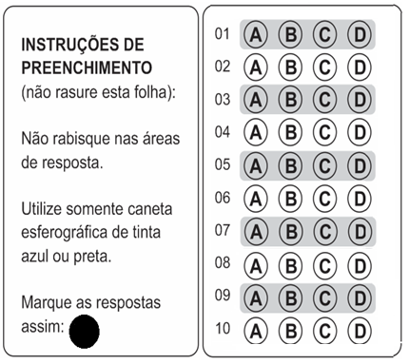
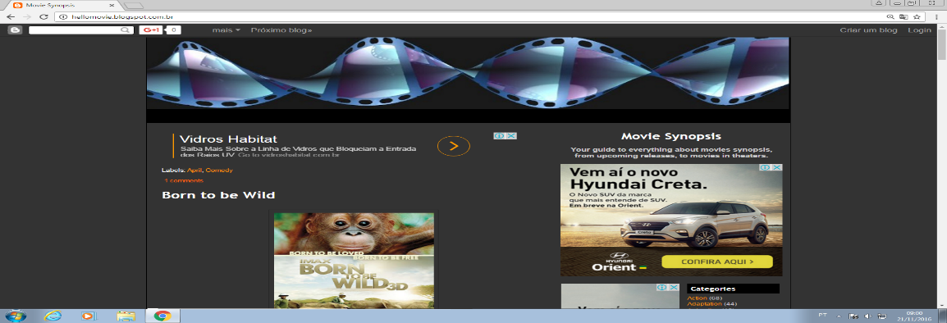
Henry’s Crime
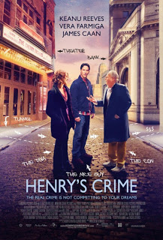
Henry, a tollbooth worker, is unknowingly roped into a bank robbery by acquaintances, and when the police show up, Henry is the only one who gets caught. During a four-year jail stint, he befriends Max, a wise, older gentleman, who leads Henry to consider his purpose in life. Upon his release, Henry returns to the bank he didn't rob, and realizes he went to jail for a crime he didn't commit. So, he might as well go ahead and commit the crime.
Genres : Comedy, Thriller and Crime/Gangster
Running Time : 1 hr. 48 min.
Release Date : April 8th, 2011
Starring : Keanu Reeves, Vera Farmiga, James Caan, Danny Hoch, Fisher Stevens
Directed by : Malcolm Venville
Produced by : Scott Fischer, Sacha Gervasi, Stephen Hays (II)
VOCABULARY: tollbooth=cabine de pedágio; unknowingly=intensionalmente; acquaintances=conhecidos; stint=restrição; befriend=tornar-se amigo.
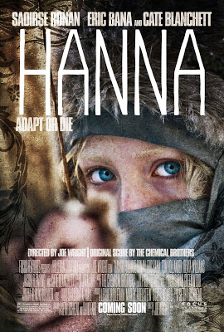

Hanna
Raised by her father, an ex-CIA man, in the wilds of Finland, Hanna's upbringing and training have been one and the same, all geared to making her the perfect assassin. The turning point in her adolescence is a sharp one; sent into the world by her father on a mission, Hanna journeys stealthily across Europe while eluding agents dispatched after her by a ruthless intelligence operative with secrets of her own. As she nears her ultimate target, Hanna faces startling revelations about her existence and unexpected questions about her humanity.
Genres : Drama and Thriller
Release Date : April 8th, 2011
Starring : Saoirse Ronan, Eric Bana, Cate Blanchett, Tom Hollander, Olivia Williams
Directed by : Joe Wright
Produced by : Leslie Holleran, Marty Adelstein, Scott Nemes
Labels: April, Drama, Thriller
VOCABULARY: upbringing=criação; geared=ajustar-se/engrenar-se; sharp=principal/afiado/decisivo; stealthily=furtivamente/secretamente; ruthless=brutal/cruel; startling=surpreendente/alarmante.

QUESTIONS

- Sobre o filme “Henry’s Crime” é ERRADO dizer que:
- É um documentário.
- É sobre um roubo de banco.
- É sobre a prisão de Henry e seu aprendizado.
- É do gênero gangster.

- O filme “Henry’s Crime”:
- Conta a história de um rapaz que foi preso injustamente.
- Conta a história de uma amizade que surge na prisão.
- Conta a saga de um jovem que foi preso injustamente e acaba cometendo o crime após sair da prisão.
- Todas as respostas acima estão corretas.

- No filme do primeiro texto:

- Henry é o gangster.
- Henry é um viciado em drogas.
- Henry é o único a ir pra cadeia.
- Henry mente para a polícia.

- Observe a frase abaixo:
Henry befriends Max, a wise, older gentleman, who leads Henry to consider his purpose in life.

Sobre este trecho podemos afirmar que:
- Henry is older than Max.
- Max is as young as Henry.
- Max is wiser than Henry.
- Henry is not so young as Max.

- Marque a frase que possui uma comparação entre Hanry e Max, onde um equivale (é igual) ao outro pela característica dada:
- Henry is more intelligent than Max.
- Henry is the most aggressive in the movie.
- Max is the wisest inmate in prision.
- Henry is as guilty as Max.
Obs: guity = culpado(a); inmate=presidiário

- Sobre o Segundo texto podemos afirmar que:
- A personagem Hanna foi criada pelo pai que era um assassino de aluguel.
- A personagem Hanna partiu numa missão dada por seu pai.
- A personagem Hanna era uma agente do FBI.
- A personagem Hanna foi abduzida por ETs e não fica mais humana.

- No final da história a personagem:
- Descobre que matou seu próprio pai.
- É sequestrada por agentes federais.
- Descobre revelações sobre sua vida.
- É morta a tiros pelo pai.

- O adjetivo sharp presente no segundo texto significa principal ou decisivo, mas pode significar afiado, agudo. Se eu quiser dizer que o momento exato da adolescência que Hanna descobre a verdade foi o mais decisivo da vida dela. Esta frase seria qual opção abaixo:
- The turning point in her adolescence when she discovers the truth is the most sharp in her life.
- The turning point in her adolescence when she discovers the truth is the sharpest in her life.
- The turning point in her adolescence when she discovers the truth is more sharp than in her life.
- The turning point in her adolescence when she discovers the truth is sharper than in her life.

- A frase que tem o comparativo de INFERIORIDADE (algo é menos que outra coisa) está na letra:
- Hanna is as cruel as her father.
- Her life is not so important as her father’s.
- Hanna is less ruthless than the agents.
- Hanna is the least ruthless in the movie.

- Marque a frase que tem um SUPERLATIVO de inferioridade (ou seja, uma coisa é o menos/menor que todas as outras):
- Hanna is the less important in the movie.
- Hanna’s father is the most cruel character.
- Hanna is the least ruthless in the movie.
- Hanna’s life is the most unexpected in the movie.

- Compare os personagens abaixo utilizando-se dos símbolos dados:
Adjetivos que podem ser utilizados:
HANDSOME/BEAUTIFUL, GREAT, POWERFUL, INTELLIGENT, STRONG, MODERN, OLD, YOUNG, CRUEL, RUTHLESS, AMERICAN, INTENSE, SHY, HOT, NEW, COMPETENT, GENEROUS, FAMOUS, GOOD, BAD, TALL, etc.
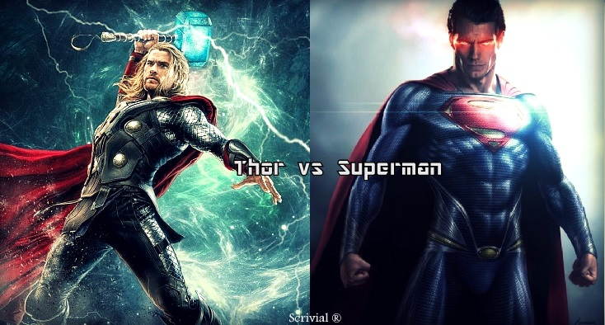
Thor = Superman ________________________________________________________
Thor = Superman ________________________________________________________
Thor +/- Superman ________________________________________________________
Superman +/- Thor ________________________________________________________
Superman > Thor ________________________________________________________
Thor > Superman ________________________________________________________
Superman > … ________________________________________________________
Thor > … ________________________________________________________
Superman < … ________________________________________________________
Thor < … ________________________________________________________
Wonderwoman = Alice ________________________________________________________
Wonderwoman = Alice ________________________________________________________
Wonderwoman +/- Alice ________________________________________________________
Wonderwoman +/- Alice ________________________________________________________
Wonderwoman > Alice ________________________________________________________
Alice > Wonderwoman ________________________________________________________
Wonderwoman > … ________________________________________________________
Alice > …
________________________________________________________
Wonderwoman < … ________________________________________________________
Alice < …
________________________________________________________

- Use o Comparativo de Superioridade.
- New York is (_____________________________) Lisbon. (big)
- Rolls Royce is (_____________________________) a Volkswagen. (expensive)
- English is (_____________________________) German. (easy)
- Peter is (_____________________________) John. (handsome)
- Coffee is (_____________________________) tea in Portugal. (popular)
- A motorbike is (_____________________________) a bike. (fast)
- Cities are (_____________________________) towns. (noisy)
- These Jeans are (_____________________________) the other ones. (good)
- A rainy day is (_____________________________) a windy day. (bad)
- Roses are (_____________________________) daisies. (bautiful)

- Use o Comparativo de Igualdade:
- The blue car is (_____________________________) the red car. (fast)
- Peter is (_____________________________) Fred. (not/tall)
- The violin is (_____________________________) the cello. (not/low)
- This copy is (_____________________________) the other one. (bad)
- Oliver is (_____________________________) Peter. (optimistic)
- Today it's (_____________________________) yesterday. (not/windy)
- The tomato soup was (_____________________________) the mushroom soup. (delicious)
- Grapefruit juice is (_____________________________) lemonade. (not/sweet)
- Nick is (_____________________________) Kevin. (brave)
- Silver is (_____________________________) good. (not/heavy)

- Preencha a tabela com o que falta
ADJETIVE | COMPARATIVO |  |  | SUPERLATIVO
 | IGUALDADE | SUPERIORIDADE | INFERIORIDADE | SUPERIORIDADE | INFERIORIDADE
CRAZY | as crazy as | crazier than | less crazy than | the craziest | the least crazy
INTERESTING | (-) not so interesting as
PEACEFUL
FULL | (-)
FRESH | (-)
HOPEFUL
ANGRY
NORTHERN | (-)
COMMON | (-)
HUNGRY
IMPORTANT

- Relacione a tabela com tipos de filmes e programas de Tv e sua definição:

- ROMCOM
- THRILLER
- SITCOM
- CARTOON
- WESTERN
- BIOPIC
- SCI-FI
- COOKERY
- MAKE OVER
- TALK SHOW
( ) Traditional romance blended with elements of comedy. Nearly always resolves with a happy ending.
( ) A film about the western United States in the 1800s, usually with cowboys.
( ) Stories whose central struggle pits an innocent hero against a lethal enemy who is out to kill him or her.
( ) A programme hosted by famous chefs, who teach people how to cook.
( ) A show that helps people change their image or lifestyle.
( ) A programme that features animated characters.
( ) Programmes hosted by a TV personality, (or host) featuring guests who talk about their lives.
( ) An amusing TV series about fictional characters. Also known as a situation comedy.
( ) A film based on the events of someone’s life
( ) Stories whose central struggle is generated from the technology and tools of a scientifically imaginable world.

RASCUNHO
_______________________________________________________________________________________
_______________________________________________________________________________________
_______________________________________________________________________________________
_______________________________________________________________________________________
_______________________________________________________________________________________
_______________________________________________________________________________________
_______________________________________________________________________________________
_______________________________________________________________________________________
_______________________________________________________________________________________
_______________________________________________________________________________________
_______________________________________________________________________________________
_______________________________________________________________________________________
_______________________________________________________________________________________
_______________________________________________________________________________________
_______________________________________________________________________________________
_______________________________________________________________________________________
_______________________________________________________________________________________
_______________________________________________________________________________________
_______________________________________________________________________________________
_______________________________________________________________________________________
_______________________________________________________________________________________
_______________________________________________________________________________________
_______________________________________________________________________________________
_______________________________________________________________________________________
_______________________________________________________________________________________
_______________________________________________________________________________________
_______________________________________________________________________________________
_______________________________________________________________________________________
_______________________________________________________________________________________
_______________________________________________________________________________________
_______________________________________________________________________________________
_______________________________________________________________________________________
_______________________________________________________________________________________
_______________________________________________________________________________________
_______________________________________________________________________________________
_______________________________________________________________________________________
_______________________________________________________________________________________
_______________________________________________________________________________________
_______________________________________________________________________________________
_______________________________________________________________________________________
_______________________________________________________________________________________
_______________________________________________________________________________________
_______________________________________________________________________________________

