

**DATA: 23 / 11 / 2016**

**ALUNO(A):**

**1º Bimestre**

**TURMA: 1º INFOR_MAT**

**PROFESSORA: CRISTIANE DE BRITO CRUZ PROVA TIPO 1**

Nota

Valor **100**

**AVALIAÇÃO BIMESTRAL .**

**INSTRUÇÕES:**

* Leia as instruções com atenção.
* Entregue junto com a prova: seu cartão de vistos e seu trabalho (não será dado outro prazo para entrega).
* Escreva seu **nome completo** com letra legível. Seus dados de identificação são importantes;
* **Não esqueça de preencher o gabarito, caso não preencha perderá a pontuação das mesmas**;
* Somente será permitido o uso de caneta esferográfica **azul** ou **preta**;
* Utilize o verso da prova para rascunho das questões **subjetivas**;
* É terminantemente proibido o uso de celulares, tablets, notebooks, caderno ou qualquer meio de consulta;
* Em havendo sinal de **cola** a avaliação será atribuída nota **0,0** para os alunos envolvidos;
* Não se preocupe em **não entender todas as palavras do texto**. Passe a “vista” rapidamente umas 3 vezes e vá para as perguntas.
* Cuidado ao conferir as palavras para **não rasurar o gabarito nem as questões subjetivas**, não será dada a você uma nova prova para passar a limpo;
* Escreva mais 10 tipos de filmes e programas de TV com a tradução (diferentes dos da prova) ou faça 10 exemplos de frases comparando que **não se encontram aqui na prova** para obter 15 pontos extras. **Obs**: não avise a quem está plicando nem pergunte nada. Faça no verso da prova onde está escrito RASCUNHO indicando aqui que fez. ( ) Eu fiz a pontuação extra.

**FOLHA DE RESPOSTAS**

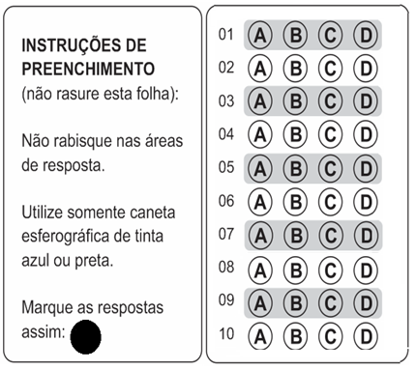

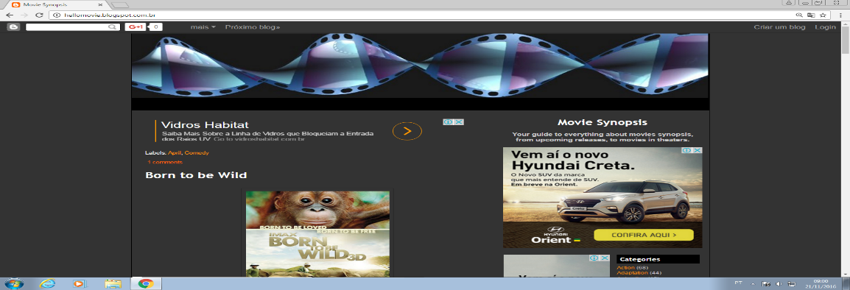 [**Born to be Wild**](http://hellomovie.blogspot.com.br/2011/03/born-to-be-wild.html)

[](http://3.bp.blogspot.com/-WVC86mu5AuE/TZC2VJNTlzI/AAAAAAAABB8/BMH-jDODRFs/s1600/born_to_be_wild_poster01.jpg)An inspired story of love, dedication and the remarkable bond between humans and animals. This film documents orphaned orangutans, elephants, and the extraordinary people who rescue and raise them - saving endangered species one life at a time. Stunningly captured in IMAX 3D, Born to be Wild 3D is a heartwarming adventure transporting moviegoers into the lush rainforests of Borneo with world-renowned primatologist Dr. Birute Galdikas, and across the rugged Kenyan savannah with celebrated elephant authority Dame Daphne Sheldrick, as they and their team rescue, rehabilitate and return these incredible animals back to the wild.

**Genres** : Documentary  
**Release** **Date** : April 8th, 2011  
**Starring** : Morgan Freeman  
**Directed** **by** : David Lickley  
**Produced** **by** : Drew Fellman

**Labels**: [April](http://hellomovie.blogspot.com.br/search/label/April), [Documentary](http://hellomovie.blogspot.com.br/search/label/Documentary)

[**VOCABULARY**:](https://www.blogger.com/comment.g?blogID=5033507339068833419&postID=1298358358381318000) Stunningly=impressionantemente; heartwarming=emocinante/comovente; moviegoer=frequentador de cinema; renowed=renomado; rugged=áspero/rude/resistente.

### [Hanna](http://hellomovie.blogspot.com.br/2011/03/hanna.html)

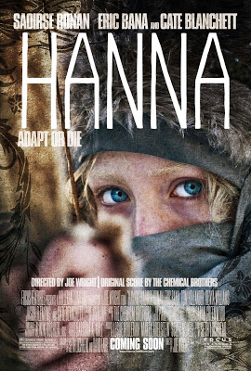Raised by her father, an ex-CIA man, in the wilds of Finland, Hanna's upbringing and training have been one and the same, all geared to making her the perfect assassin. The turning point in her adolescence is a sharp one; sent into the world by her father on a mission, Hanna journeys stealthily across Europe while eluding agents dispatched after her by a ruthless intelligence operative with secrets of her own. As she nears her ultimate target, Hanna faces startling revelations about her existence and unexpected questions about her humanity.

**Genres** : Drama and Thriller  
**Release** **Date** : April 8th, 2011  
**Starring** : Saoirse Ronan, Eric Bana, Cate Blanchett, Tom Hollander, Olivia Williams  
**Directed** **by** : Joe Wright  
**Produced** **by** : Leslie Holleran, Marty Adelstein, Scott Nemes

**Labels**: [April](http://hellomovie.blogspot.com.br/search/label/April), [Drama](http://hellomovie.blogspot.com.br/search/label/Drama), [Thriller](http://hellomovie.blogspot.com.br/search/label/Thriller)

[2 comments](https://www.blogger.com/comment.g?blogID=5033507339068833419&postID=6965947076852713721)

[**VOCABULARY**:](https://www.blogger.com/comment.g?blogID=5033507339068833419&postID=1298358358381318000) upbringing=criação; geared=ajustar-se/engrenar-se; sharp=principal/afiado/decisivo; stealthily=furtivamente/secretamente; ruthless=brutal/cruel; startling=surpreendente/alarmante.

**QUESTIONS**

1. O filme “Born to be wild” é ERRADO dizer que:
2. É um documentário.
3. Fala a respeito de macacos e elefantes.
4. Foi filmado no Kenya.
5. Fala do maltrato aos animais.
6. O filme “Born to be wild”:
7. Conta a história de pessoas que resgatam animais em risco.
8. Conta a saga dos orangotangos contra os elefantes.
9. Conta sobre profissionais renomados que resgatam, cuidam e devolvem a natureza animais no Kenya.
10. Todas as respostas acima estão corretas.
11. Observe o trecho abaixo:

***An inspired story of love, dedication and the remarkable bond between humans and animals.***

O adjetivo ***remarkable*** está destacado na frase. Para dizer que os seres humanos que se dedicam a estes animais são **notáveis**, **extraordinários**. Se eu quisesse construir uma frase que diga que ***estas pessoas são as mais notáveis do planeta***, que opção abaixo trará esta frase:

1. These people are **the best** remarkable people in the Planet.
2. These people are **the most** remarkable people in the Planet.
3. These people are **the** remarkabl**est** people in the Planet.
4. These people are **more** remarkable **than** people in the Planet.
5. Observe a frase abaixo:

*These people are* ***more*** *extraordinary* ***than*** *veterinarians who take care of people’s pets.*

Esta frase significa que as pessoas que o texto 01 se refere são:

1. Tão extraordinárias quanto os veterinários que cuidam dos animais domésticos das pessoas.
2. Não são tão extraordinárias quanto os veterinários que cuidam dos animais domésticos das pessoas.
3. Tão extraordinárias quanto os veterinários que cuidam dos animais domésticos das pessoas.
4. Mais extraordinárias do que os veterinários que cuidam dos animais domésticos das pessoas.
5. Os mais extraordinários veterinários que cuidam dos animais domésticos das pessoas.
6. Marque a frase que possui uma comparação entre dois animais, onde um equivale (é igual) ao outro pela característica dada:
7. Orangutans are **more** intelligent **than** gorillas.
8. Elephants are **the** **least** aggressive animals in the forest.
9. Orangutans are **the** smart**est** animals in the forest.
10. Orangutans are **as** strong **as** gorillas.
11. Sobre o Segundo texto podemos afirmar que:
12. A personagem Hanna foi criada pelo pai que era um assassino de aluguel.
13. A personagem Hanna partiu numa missão dada por seu pai.
14. A personagem Hanna era uma agente do FBI.
15. A personagem Hanna foi abduzida por ETs e não fica mais humana.
16. No final da história a personagem:
17. Descobre que matou seu próprio pai.
18. É sequestrada por agentes federais.
19. Descobre revelações sobre sua vida.
20. É morta a tiros pelo pai.
21. O adjetivo ***sharp*** presente no segundo texto significa principal ou decisivo, mas pode significar afiado, agudo. Se eu quiser dizer que o momento exato da adolescência que Hanna descobre a verdade foi **o mais decisivo da vida dela**. Esta frase seria qual opção abaixo:
22. The turning point in her adolescence when she discovers the truth is **the most** sharp in her life.
23. The turning point in her adolescence when she discovers the truth is **the** sharp**est** in her life.
24. The turning point in her adolescence when she discovers the truth is **more** sharp **than** in her life.
25. The turning point in her adolescence when she discovers the truth is sharp**er than** in her life.
26. A frase que tem o comparativo de INFERIORIDADE (algo é menos que outra coisa) está na letra:
27. Hanna is as cruel as her father.
28. Her life is not so important as her father’s.
29. Hanna is less ruthless than the agents.
30. Hanna is the least ruthless in the movie.
31. Marque a frase que tem um SUPERLATIVO de inferioridade (ou seja, uma coisa é o menos/menor que todas as outras):
32. Hanna is the less important in the movie.
33. Hanna’s father is the most cruel character.
34. Hanna is the least ruthless in the movie.
35. Hanna’s life is the most unexpected in the movie.
36. Compare os personagens abaixo utilizando-se dos símbolos dados:

Adjetivos que podem ser utilizados:

**HANDSOME/BEAUTIFUL, GREAT, POWERFUL, INTELLIGENT, STRONG, MODERN, OLD, YOUNG, CRUEL, RUTHLESS, AMERICAN, INTENSE, SHY, HOT, NEW, COMPETENT, GENEROUS, FAMOUS, GOOD, BAD, TALL, etc**.

Batman = Superman ________________________________________________________

Batman = Superman ________________________________________________________

Batman +/- Superman ________________________________________________________

Superman +/- Batman ________________________________________________________

Superman > Batman ________________________________________________________

Batman > Superman ________________________________________________________

Superman > … ________________________________________________________

Batman > … ________________________________________________________

Superman < … ________________________________________________________

Batman < … ________________________________________________________



Wonderwoman = Alice ________________________________________________________

Wonderwoman = Alice ________________________________________________________

Wonderwoman +/- Alice ________________________________________________________

Wonderwoman +/- Alice ________________________________________________________

Wonderwoman > Alice ________________________________________________________

 Alice > Wonderwoman ________________________________________________________

Wonderwoman > … ________________________________________________________

Alice > …

________________________________________________________

Wonderwoman < … ________________________________________________________

Alice < …

________________________________________________________

1. Use o Comparativo de **Superioridade**.
2. New York is (_____________________________) Lisbon. (big)
3. Rolls Royce is (_____________________________) a Volkswagen. (expensive)
4. English is (_____________________________) German. (easy)
5. Peter is (_____________________________) John. (handsome)
6. Coffee is (_____________________________) tea in Portugal. (popular)
7. A motorbike is (_____________________________) a bike. (fast)
8. Cities are (_____________________________) towns. (noisy)
9. These Jeans are (_____________________________) the other ones. (good)
10. A rainy day is (_____________________________) a windy day. (bad)
11. Roses are (_____________________________) daisies. (bautiful)
12. Use o Comparativo de **Igualdade**:
13. The blue car is (_____________________________) the red car. (fast)
14. Peter is (_____________________________) Fred. (not/tall)
15. The violin is (_____________________________) the cello. (not/low)
16. This copy is (_____________________________) the other one. (bad)
17. Oliver is (_____________________________) Peter. (optimistic)
18. Today it's (_____________________________) yesterday. (not/windy)
19. The tomato soup was (_____________________________) the mushroom soup. (delicious)
20. Grapefruit juice is (_____________________________) lemonade. (not/sweet)
21. Nick is (_____________________________) Kevin. (brave)
22. Silver is  (_____________________________) good. (not/heavy)
23. Preencha a tabela com o que falta

|  |  |  |  |  |  |
| --- | --- | --- | --- | --- | --- |
| **ADJETIVE** | **COMPARATIVO** | | | **SUPERLATIVO** | |
| **IGUALDADE** | **SUPERIORIDADE** | **INFERIORIDADE** | **SUPERIORIDADE** | **INFERIORIDADE** |
| **CRAZY** | as crazy as | crazier than | less crazy than | the craziest | the least crazy |
| **INTERESTING** | (-) not so interesting as |  |  |  |  |
| **PEACEFUL** |  |  |  |  |  |
| **FULL** | (-) |  |  |  |  |
| **FRESH** | (-) |  |  |  |  |
| **HOPEFUL** |  |  |  |  |  |
| **ANGRY** |  |  |  |  |  |
| **NORTHERN** | (-) |  |  |  |  |
| **COMMON** | (-) |  |  |  |  |
| **HUNGRY** |  |  |  |  |  |
| **IMPORTANT** |  |  |  |  |  |

1. Relacione a tabela com tipos de filmes e programas de Tv e sua definição:
2. ROMCOM
3. THRILLER
4. SITCOM
5. CARTOON
6. WESTERN
7. BIOPIC
8. SCI-FI
9. COOKERY
10. MAKE OVER
11. TALK SHOW

( ) Traditional romance blended with elements of comedy. Nearly always resolves with a happy ending.

( ) A film about the western United States in the 1800s, usually with cowboys.

( ) Stories whose central struggle pits an innocent hero against a lethal enemy who is out to kill him or her.

( ) A programme hosted by famous chefs, who teach people how to cook.

( ) A show that helps people change their image or lifestyle.

( ) A programme that features animated characters.

( ) Programmes hosted by a TV personality, (or host) featuring guests who talk about their lives.

( ) An amusing TV series about fictional characters. Also known as a situation comedy.

( ) A film based on the events of someone’s life

( ) Stories whose central struggle is generated from the technology and tools of a scientifically imaginable world.

**RASCUNHO**

_______________________________________________________________________________________

_______________________________________________________________________________________

_______________________________________________________________________________________

_______________________________________________________________________________________

_______________________________________________________________________________________

_______________________________________________________________________________________

_______________________________________________________________________________________

_______________________________________________________________________________________

_______________________________________________________________________________________

_______________________________________________________________________________________

_______________________________________________________________________________________

_______________________________________________________________________________________

_______________________________________________________________________________________

_______________________________________________________________________________________

_______________________________________________________________________________________

_______________________________________________________________________________________

_______________________________________________________________________________________

_______________________________________________________________________________________

_______________________________________________________________________________________

_______________________________________________________________________________________

_______________________________________________________________________________________

_______________________________________________________________________________________

_______________________________________________________________________________________

_______________________________________________________________________________________

_______________________________________________________________________________________

_______________________________________________________________________________________

_______________________________________________________________________________________

_______________________________________________________________________________________

_______________________________________________________________________________________

_______________________________________________________________________________________

_______________________________________________________________________________________

_______________________________________________________________________________________

_______________________________________________________________________________________

_______________________________________________________________________________________

_______________________________________________________________________________________

_______________________________________________________________________________________

_______________________________________________________________________________________

_______________________________________________________________________________________

_______________________________________________________________________________________

_______________________________________________________________________________________

_______________________________________________________________________________________

_______________________________________________________________________________________

_______________________________________________________________________________________