
ALUNO(A):
TURMA: 4º ALIM_VESP
DATA: 28 / 06 / 2016
1º Bimestre

PROFESSORA: CRISTIANE DE BRITO CRUZ PROVA TIPO 4

Valor 100
Nota

AVALIAÇÃO BIMESTRAL .

INSTRUÇÕES:

- Leia as instruções com atenção.
- Escreva seu nome completo com letra legível. Seus dados de identificação são importantes;
- Não esqueça de preencher o gabarito, caso não preencha perderá a pontuação das mesmas;
- Somente será permitido o uso de caneta esferográfica azul ou preta;
- É terminantemente proibido o uso de celulares, tablets, notebooks, caderno ou qualquer meio de consulta;
- Em havendo sinal de cola a avaliação será atribuída nota 0,0 para os alunos envolvidos;
- Não se preocupe em não entender todas as palavras do texto. Passe a “vista” rapidamente umas 3 vezes e vá para as perguntas.
- Cuidado ao conferir as palavras para não rasurar o gabarito, não será dada a você uma nova prova para passar a limpo (rasure as questões objetivas na prova e rabisque e circule o texto o quanto quiser, mas mantenha o gabarito sem rabiscos e não rasure as questões subjetivas (sem rabiscos, sem corretivo);
- Este item é para ver quem gosta de ler as instruções: você não deverá avisar a ninguém nem falar comigo sobre isto durante a aplicação da prova: escreva em inglês e em português 15 verbos (diferentes dos da prova) juntamente com sua forma de passado e ganhe pontuação extra. Sendo 8 verbos regulares e 7 irregulares. Se você falar para alguém ou comigo você irá perder a pontuação. Utilize o espaço em branco na última página para escrever. Caso não saiba forme 15 frases no passado (simples, perfeito ou to be) usando seu nome ou nome dos colegas, servidores e professores. Podem ser frases simples e pequenas como I saw you yesterday (eu te vi ontem). Traduza as frases. Boa prova!!!!!

FOLHA DE RESPOSTAS

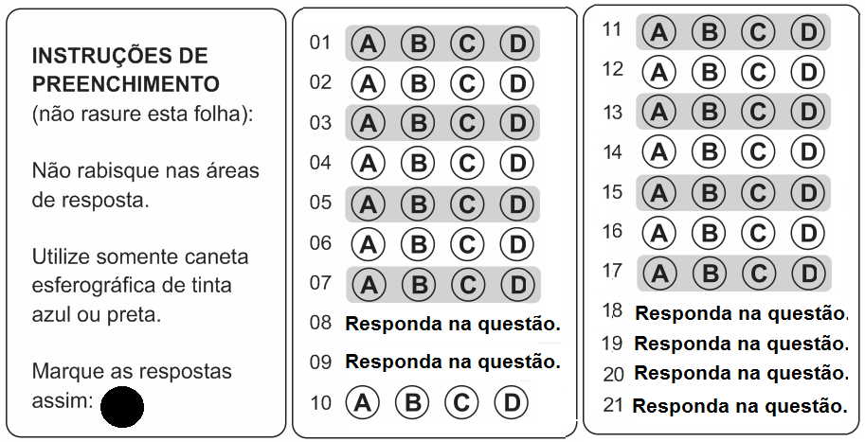

Leia com atenção e observe as perguntas para responder.


Sick on Saturday
I have just had a terrible weekend! On Saturday I was so tired that I slept all morning. When I woke up I had a headache and my throat was sore. My body ached all over. My nose ran and I coughed a lot. My mother took my temperature but I did not have a fever. My father had worked and when he came back home my mother was doing soup to me. He was very worried.

My mother had made me some soup for lunch and I ate it in bed. I drank some juice. I tried to read a book but I couldn’t keep my eyes open. I lay in bed all afternoon. I drifted in and out of sleep. I drank more juice. I felt miserable all afternoon. I didn’t want to do anything. My boyfriend had called me but I couldn’t answer because my throat ached too much. I was sleeping when he came in my house but my mother said I wasn’t ok for seeing him, so he went back to his house.

I got out of bed at dinner time. My parents ordered pizza for dinner and I was able to eat some of it. I drank more juice! I felt a bit better after dinner so I stayed up. I snuggled under a blanket on the couch and watched some TV with my parents. I fell asleep in front of the TV.

The next morning I felt better but now my mother had a cold! She looked miserable. It was her turn to be sick.
http://www.readingesl.ca/grammar/past.htm
VOCABULARY:

Headache: dor de cabeça
Throat: garganta
Coughed: passado de couch = tossir
Fever: febre
Worried: passado de preocupar
Soup: sopa
Couldn’t: não poder
Lay; deitar
Drifted: passado de drift = cochilar
Called: passado de call = chamar, telefonar
Ached: passado de ache = doer
Ordered: passado de order = pedir
Snuggled: passado de snuggle = açoar
Blanket: lençol

- O que houve com esta moça da foto:
- Ela foi assaltada na porta de casa.
- Ela brigou com o namorado.
- Ela ficou doente no fim-de-semana.
- Nenhuma das respostas anteriores está correta.

- Observe a frase abaixo:
When I woke up I had a headache and my throat was sore. My body ached all over. My nose ran and I coughed a lot. My mother took my temperature but I did not have a fever. My father had worked and when he came back he was very worried with me.

Na frase:
- Ela ficou doente e depois a mãe veio cuidar dela.
- O pai dela cuidou dela quando ele chegou do trabalho.
- Ela pegou gripe do namorado dela.
- Nenhuma das respostas anteriores está correta.
- Observe o trecho abaixo:
My mother took my temperature but I did not have a fever. My father had worked and when he came back my mother was doing the soup for me. He was very worried.

- A ação dos dois primeiros verbos destacados aconteceu antes da ação do verbo que acompanha HAD.
- A ação dos dois primeiros verbos destacados aconteceu depois da ação do verbo que acompanha HAD.
- As duas ações após o verbo que acompanha HAD estão incompletas.
- Nenhuma das respostas anteriores está correta.

- Os pais desta mulher:
- Estavam em casa na hora que ela estava doente.
- Ficaram muito preocupados com ela.
- Não cuidaram dela.
- Não estavam juntos na hora que ela estava doente.

- Observe a frase abaixo:
My mother had made me some soup for lunch and I ate it in bed. I drank some juice. I tried to read a book but I couldn’t keep my eyes open. I lay in bed all afternoon.

Na frase:
- A mulher tomou sopa e uma taça de vinho.
- A mulher leu um livro e foi dormir.
- A mulher ficou deitada a tarde inteira.
- A mulher foi hospitalizada.

- Observe a frase abaixo:
My boyfriend had called me but I couldn’t answer because my throat ached too much. I was sleeping when he came in my house but my mother said I wasn’t ok for seeing him, so he went back to his house.

- O namorado dela veio na casa dela e depois ligou pra saber como ela estava.
- O namorado dela ligou e ela disse que não queria vê-lo naquele dia.
- O namorado dela foi na casa dela, mas a mãe dela disse que ela não estava bem e ele foi embora.
- O namorado dela entrou e ficou no quarto com ela uns momentos, no outro dia ele adoeceu.

- No final da história:
- A mulher melhorou após a visita do namorado.
- Ela comeu pizza e ficou em frente a TV após o jantar.
- Ela encontrou com seu namorado e eles viram TV.
- A mãe dela adoeceu por ter cuidado dela.

- Responda em inglês sobre o segundo texto:

- What day was this woman sick?
________________________________________________________________________
- Did she wake up early(cedo)?
________________________________________________________________________
- Had she had breakfast in the morning?
________________________________________________________________________
- Had she gone to a party at night?
________________________________________________________________________
- Did she have a fever?
_______________________________________________________________________
- Did she read a book in the bed?
________________________________________________________________________
- Did she answer the phone when her boyfriend called?
________________________________________________________________________
- Had her mother said for her boyfriend to see this girl?
________________________________________________________________________
- Had the boyfriend visited her the day before?
_______________________________________________________________________
- Did she fall asleep in front of the TV?
________________________________________________________________________

- Responda sobre você ou sobre alguém que se pede:
- Were you in the English class yesterday?
________________________________________________________________________
- Did you study for this test?
________________________________________________________________________
- Had you read the texts before this test?
________________________________________________________________________
- Was Cristiane at IFRN yesterday?
________________________________________________________________________
- Did you know Cristiane before she was your teacher?
________________________________________________________________________
- Was Andreilson the Main Director (DG) in December 2015?
________________________________________________________________________
- Did you do all the English activities?
________________________________________________________________________
- Were you prepared for the test yesterday?
________________________________________________________________________
- Had you done the exercises before this test?
________________________________________________________________________

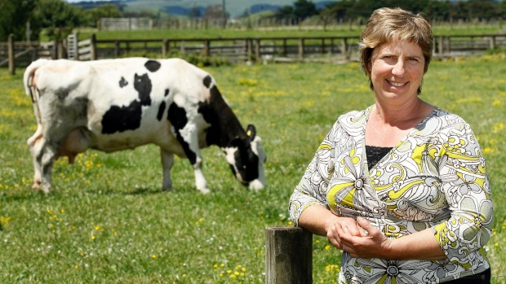
A Life-Saving Cow
Six consecutive days of spring rain had created a raging river running by Nancy Brown's farm. As she tried to herd her cows to higher ground, she slipped and hit her head on a fallen tree trunk. The fall knocked her out for a moment or two. When she came to, Lizzie, one of her oldest and favorite cows, was licking her face. The water was rising. Nancy got up and began walking slowly with Lizzie. The water was now waist high. Nancy's pace got slower and slower. Finally, all she could do was to throw her arm around Lizzie's neck and try to hang on. About 20 minutes later, Lizzie managed to successfully pull herself and Nancy out of the raging water and onto a bit of high land, a small island now in the middle of acres of white water.
Even though it was about noon, the sky was so dark and the rain and lightning so bad that it took rescuers another two hours to discover Nancy. A helicopter lowered a paramedic, who attached Nancy to a life-support hoist. They raised her into the helicopter and took her to the school gym, where the Red Cross had set up an emergency shelter.
When the flood subsided two days later, Nancy immediately went back to the "island." Lizzie was gone. She was one of 19 cows that Nancy lost. "I owe my life to her," said Nancy sobbingly.
http://www.rong-chang.com/qa2/stories/story003.htm

- O texto fala a respeito de:
- Uma mulher que sofreu um acidente e foi salva por uma vaca.
- Uma mulher que se recusou a dar sua vaca pro abate e fugiu com ela.
- Uma mulher que adotou uma vaca como sua filha.
- Uma mulher que trocou o marido para viver numa fazenda com suas vacas.

- Diz no texto que o resgate chegou apenas:
- Só chegou ao meio dia e a mulher precisava de socorro desde as 6h da manhã. Para salvar a mulher e deixou sua vaca para morrer.
- Após um dia de espera e ela teve apenas a vaca como companhia.
- Todas as respostas acima estão INCORRETAS.

- A mulher foi salva por Lizzie:
- Que a levou em segurança para um espaço mais alto onde a chuva não havia inundado o terreno.
- Que era sua vaca preferia.
- Que lambeu sua cara acordando a mulher de um desmaio.
- Todas as respostas acima estão CORRETAS.

- Observe o trecho abaixo:
A helicopter lowered a paramedic, who attached Nancy to a life-support hoist. They raised her into the helicopter and took her to the school gym, where the Red Cross had set up an emergency shelter.

- As quatro primeiras ações destacadas aconteceram depois da última que tem o verbo HAD.
- Os quatro primeiros verbos estão no passado simples.
- O último verbo destacado que acompanha HAD está no passado perfeito.
- Todas as respostas acima estão CORRETAS.

- Observe o trecho abaixo:
Nancy's pace got slower and slower. Finally, all she could do was to throw her arm around Lizzie's neck and try to hang on.

Nancy conseguiu salvar-se:
- Por que a chuva parou e ela conseguiu então ser vista pelos paramédicos – ela estava encostada em sua vaquinha querida.
- Por que andou devagar e conseguiu colocar a mão no pescoço de Lizzie com isso que a levou a um local seguro.
- Por que a vaca consegui milagrosamente coloca-la montada em suas costas e levou-a para um lugar mais alto.
- Todas as respostas acima estão INCORRETAS.

- Na frase “The water was now waist high”:
Diz que a chuva era tão grande que a água:
- Estava na altura dos joelhos.
- Estava na altura do ombro.
- Estava na altura do pescoço.
- Estava na altura da cintura.

- Observe o trecho abaixo:
When the flood subsided two days later, Nancy immediately went back to the "island." Lizzie was gone. She was one of 19 cows that Nancy lost. "I owe my life to her," said Nancy sobbingly.

Os verbos destacados em negrito:
- Estão no passado simples apenas.
- Estão no passado do verbo to be apenas.
- Estão no passado perfeito apenas.
- Estão no passado simples e no passado do verbo to be.

- Observe o trecho abaixo:
As she tried to herd her cows to higher ground, she slipped and hit her head on a fallen tree trunk. The fall knocked her out for a moment or two.

De acordo com a sequência dos eventos eu poderia fazer uma nova frase a partir da frase sublinhada corretamente assim:
- She had tried to save her cows before she slipped and hit her head on a fallen trunk.
- She was trying to save her cows but she slipped and hit her head on a fallen trunk.
- She had tried to save her cows after she had slipped and had hit her head on a fallen trunk.
- She tried to save her cows and she slipped and hit her head on a fallen trunk.

- Passe as frases do texto para as formas que se pede:
- Six consecutive days of spring rain had created a raging river running by Nancy Brown's farm. (NEGATIVA)
_________________________________________________________________________________
- She slipped and hit her head on a fallen tree trunk. (INTERROGATIVA)
_________________________________________________________________________________
- The fall knocked her out for a moment or two. (NEGATIVA)
_________________________________________________________________________________
- The water was now waist high. (INTERROGATIVA)
_________________________________________________________________________________
- The train left at 8.20. (NEGATIVA)
_________________________________________________________________________________
- The sky wasn’t so dark and the rain and lightning weren’t so bad. (AFIRMATIVA)
_________________________________________________________________________________
- It took rescuers two hours to discover Nancy. (INTERROGATIVA)
_________________________________________________________________________________
- Red Cross had set up an emergency shelter. (NEGATIVA)
________________________________________________________________________________
- Lizzie had died when Nancy got in the Farm again. (INTERROGATIVA)
________________________________________________________________________________
- Nancy didn’t cry when she heard about Lizzie’s death. (AFIRMATIVA)
_________________________________________________________________________________

- Passe as frases abaixo para o passado:
- I am very proud of David.
_________________________________________________________________________________
- Mary goes to school by bus.
_________________________________________________________________________________
- They have been working here.
_________________________________________________________________________________
- Marcos is a very good teacher.
_________________________________________________________________________________
- Christine has gone to work satisfied.
________________________________________________________________________________
- Peter leaves his work at 6p.m.
_________________________________________________________________________________
- Andrew works at the train station.
________________________________________________________________________________
- Mary arranges a meeting at UFRN for discussing about the students.
_________________________________________________________________________________

- Retire dos dois textos:
- Duas frases no passado perfeito.
_______________________________________________________________________________
_______________________________________________________________________________

- Duas frases no passado simples (verbo regular)
_______________________________________________________________________________
_______________________________________________________________________________

- Duas frases no passado simples (verbo irregular)
_______________________________________________________________________________
_______________________________________________________________________________

- Duas frases no passado do verbo to be (singular)
_______________________________________________________________________________
_______________________________________________________________________________

- Duas frases no passado do verbo to be (plural)
_______________________________________________________________________________
_______________________________________________________________________________

- Complete corretamente a tabela:
VERBO | PASSADO | PARTICÍPIO | TRADUÇÃO
Break |  | Broken | Quebrar
Come | Came | Come
Do |  | Done | Do
 | Flew | Flown | Voar
Get | Got |  | Conseguir
 | Had | Had | ter
Know | Knew |  | Saber
Make | Made | Made
 | Ran | Run | Corer
Say |  | Said | Dizer
See | Saw |  | Ver
Tell |  | Told | Dizer, contar
Think | Thought | Thought
Wake |  | Woken | Acordar, despertar
Write | Wrote | Written

Auto-avaliação:
Seu desempenho na disciplina de língua inglesa merece o total de que nota?
CRITÉRIOS DE PONTUAÇÃO INDIVIDUAL | VALOR | QUANTO VOCÊ ACHA QUE MERECE
Participação em C.A. | 15
Participação em sala: | 15
Exercícios resolvidos em casa: | 15
Horas de estudo em casa: | 15
Estudo para esta prova: | 15
Dedicação em fazer suas apresentações: | 15
Compreensão geral do conteúdo: | 10
TOTAL | 100

